LAB PRACTICE – CO4 AT2
JAVA PROGRAMMING
NAME : U subiksha
REG NO : 192424135

- JAVA APPLET LIFECYCLE

Java Applet Lifecycle Program
import java.applet.Applet;
import java.awt.Graphics;

public class LifeCycleApplet extends Applet {

public void init() {
System.out.println("init() called");
}

public void start() {
System.out.println("start() called");
}

public void paint(Graphics g) {
g.drawString("Applet Life Cycle", 50, 50);
g.drawString("paint() called", 50, 80);
System.out.println("paint() called");
}

public void stop() {
System.out.println("stop() called");
}

public void destroy() {
System.out.println("destroy() called");
}
}

HTML File

<html>
<body>
<applet code="AppletLifeCycle.class" width="400" height="300">
</applet>
</body>
</html>

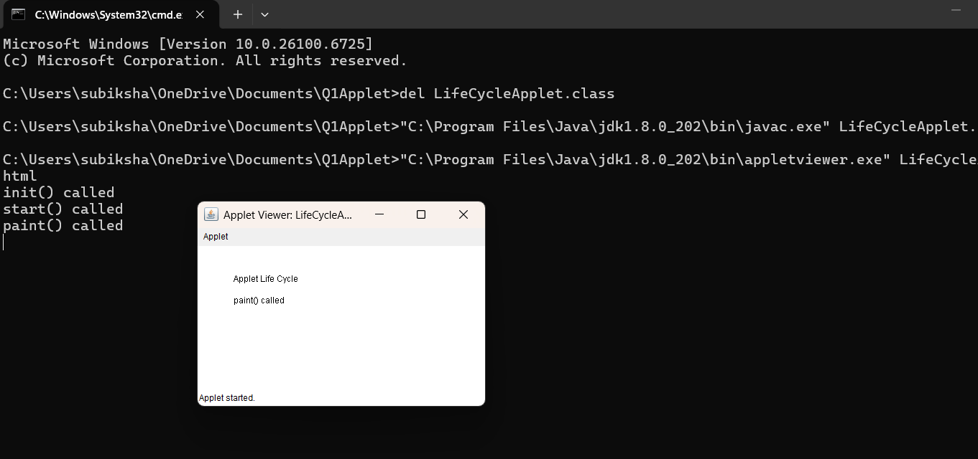

- Generating Graphic Images Using Applet
GraphicsApplet.java

import java.applet.Applet;
import java.awt.Graphics;

public class SceneApplet extends Applet {

public void paint(Graphics g) {
g.drawString("Q2 Applet Working!", 100, 100);
g.drawRect(50, 50, 200, 100);
}

HTML

<html>
<body>
<applet code="SceneApplet.class" width="600" height="400">
</applet>
</body>
</html>
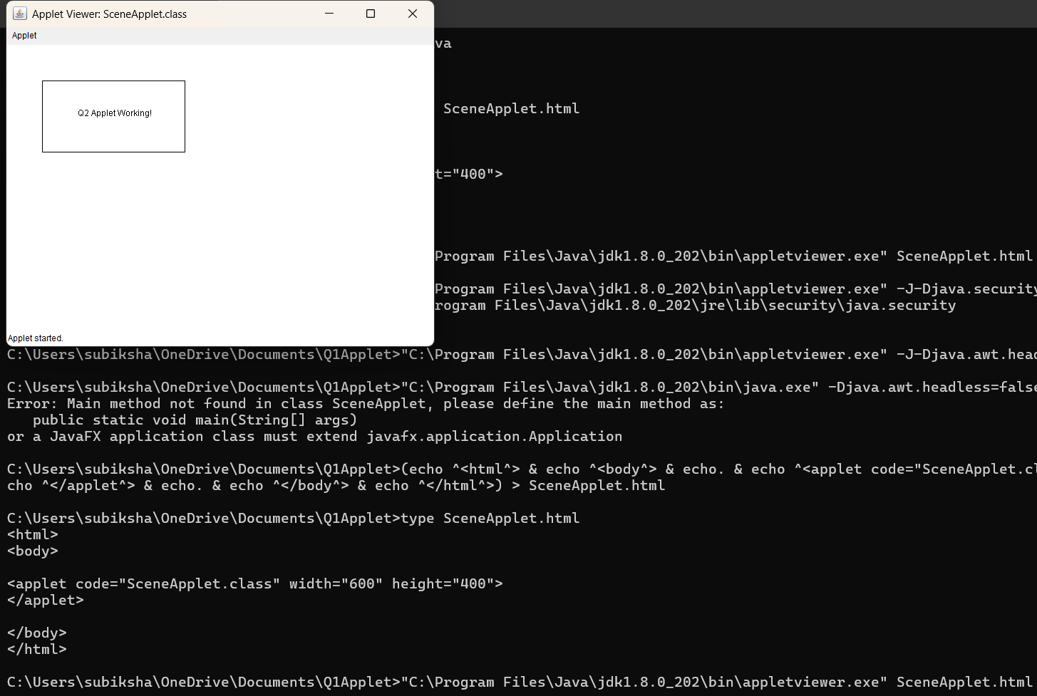

- Java Applet Calculator Using Parameters

CalculatorApplet.java

import java.applet.Applet;

import java.awt.Graphics;

public class CalculatorApplet extends Applet

{

int num1, num2, sum, sub, mul, div;

public void init()

{

num1 = Integer.parseInt(getParameter("num1"));

num2 = Integer.parseInt(getParameter("num2"));

sum = num1 + num2;

sub = num1 - num2;

mul = num1 * num2;

if(num2 != 0)

div = num1 / num2;

}

public void paint(Graphics g)

{

g.drawString("Calculator Using Applet Parameters", 50, 50);

g.drawString("First Number = " + num1, 50, 80);

g.drawString("Second Number = " + num2, 50, 110);

g.drawString("Addition = " + sum, 50, 150);

g.drawString("Subtraction = " + sub, 50, 180);

g.drawString("Multiplication = " + mul, 50, 210);

if(num2 != 0)

g.drawString("Division = " + div, 50, 240);

else

g.drawString("Division by Zero Not Possible", 50, 240);

}

}

CalculatorApplet.html

<html>

<body>

<applet code="CalculatorApplet.class"

width="500"

height="300">

<param name="num1" value="20">

<param name="num2" value="10">

</applet>

</body>

</html>

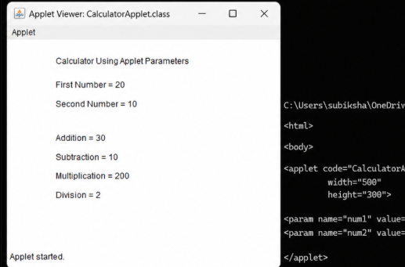

- Student Profile Using AWT Components

import java.awt.*;

import java.awt.event.*;

public class StudentProfile extends Frame implements ActionListener {

Label nameLabel, regLabel, genderLabel;

Label deptLabel, yearLabel, skillsLabel;

TextField nameField;

TextField regField;

CheckboxGroup genderGroup;

Checkbox male, female;

Choice department;

Choice year;

Checkbox java, python, cpp;

TextArea reportArea;

Button generateButton;

Button clearButton;

List skillList;

public StudentProfile() {

setTitle("Student Profile");

setSize(600, 600);

setLayout(new FlowLayout());

nameLabel = new Label("Name:");

nameField = new TextField(30);

regLabel = new Label("Register Number:");

regField = new TextField(20);

genderLabel = new Label("Gender:");

genderGroup = new CheckboxGroup();

male = new Checkbox("Male", genderGroup, false);

female = new Checkbox("Female", genderGroup, false);

deptLabel = new Label("Department:");

department = new Choice();

department.add("AI & DS");

department.add("CSE");

department.add("ECE");

department.add("IT");

department.add("EEE");

// Year

yearLabel = new Label("Year:");

year = new Choice();

year.add("1st Year");

year.add("2nd Year");

year.add("3rd Year");

year.add("4th Year");

// Skills

skillsLabel = new Label("Skills:");

java = new Checkbox("Java");

python = new Checkbox("Python");

cpp = new Checkbox("C++");

// List

skillList = new List(4);

skillList.add("Java");

skillList.add("Python");

skillList.add("C++");

skillList.add("SQL");

// Report area

reportArea = new TextArea(10, 45);

// Buttons

generateButton = new Button("Generate Report");

clearButton = new Button("Clear");

generateButton.addActionListener(this);

clearButton.addActionListener(this);

// Add components

add(nameLabel);

add(nameField);

add(regLabel);

add(regField);

add(genderLabel);

add(male);

add(female);

add(deptLabel);

add(department);

add(yearLabel);

add(year);

add(skillsLabel);

add(java);

add(python);

add(cpp);

add(new Label("Programming Languages:"));

add(skillList);

add(generateButton);

add(clearButton);

add(reportArea);

addWindowListener(new WindowAdapter() {

public void windowClosing(WindowEvent e) {

dispose();

}

});

setVisible(true);

}

public void actionPerformed(ActionEvent e) {

if (e.getSource() == generateButton) {

String gender = "";

if (male.getState())

gender = "Male";

else if (female.getState())

gender = "Female";

String skills = "";

if (java.getState())

skills += "Java ";

if (python.getState())

skills += "Python ";

if (cpp.getState())

skills += "C++ ";

reportArea.setText(

"STUDENT PROFILE\n\n" +

"Name: " + nameField.getText() + "\n" +

"Register Number: " + regField.getText() + "\n" +

"Gender: " + gender + "\n" +

"Department: " + department.getSelectedItem() + "\n" +

"Year: " + year.getSelectedItem() + "\n" +

"Skills: " + skills + "\n" +

"Selected List Item: " +

skillList.getSelectedItem()

);

}

else if (e.getSource() == clearButton) {

nameField.setText("");

regField.setText("");

reportArea.setText("");

male.setState(false);

female.setState(false);

java.setState(false);

python.setState(false);

cpp.setState(false);

}

}

public static void main(String[] args) {

new StudentProfile();

}

}

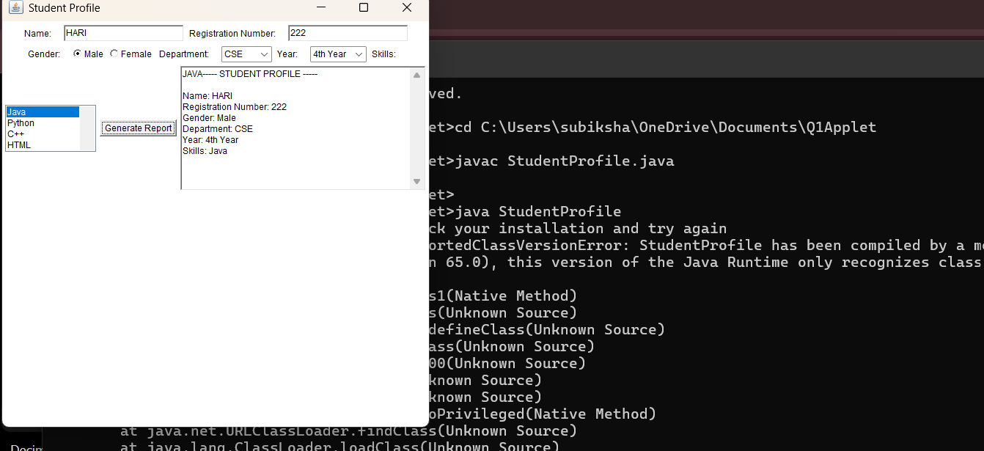

- GridLayout with Event Handling

CODE
import java.awt.*;
import java.awt.event.*;

public class GridCalculator extends Frame implements ActionListener {
TextField display;
double num1 = 0;
double num2 = 0;
String operator = "";
public GridCalculator() {
setTitle("GridLayout Calculator");
setSize(400, 500);
setLayout(new BorderLayout());
display = new TextField();
display.setEditable(false);
add(display, BorderLayout.NORTH);
Panel panel = new Panel();
panel.setLayout(new GridLayout(4, 4, 5, 5));
String[] buttons = {
"7", "8", "9", "+",
"4", "5", "6", "-",
"1", "2", "3", "*",
"0", "=", "C", "/"
};
for (String text : buttons) {
Button button = new Button(text);
button.addActionListener(this);
panel.add(button);
}
add(panel, BorderLayout.CENTER);
addWindowListener(new WindowAdapter() {
public void windowClosing(WindowEvent e) {
dispose();
}
});
setVisible(true);
}
public void actionPerformed(ActionEvent e) {
String value = e.getActionCommand();

if (value.equals("C")) {
display.setText("");
num1 = 0;
num2 = 0;
operator = "";
}
else if (value.equals("+") ||
value.equals("-") ||
value.equals("*") ||
value.equals("/")) {
num1 = Double.parseDouble(display.getText());
operator = value;
display.setText("");
}
else if (value.equals("=")) {
num2 = Double.parseDouble(display.getText());
double result = 0;
if (operator.equals("+"))
result = num1 + num2;
else if (operator.equals("-"))
result = num1 - num2;
else if (operator.equals("*"))
result = num1 * num2;
else if (operator.equals("/")) {
if (num2 != 0)
result = num1 / num2;
else {
display.setText("Cannot divide by zero");
return;
}
}
display.setText(String.valueOf(result));
}
else {
display.setText(display.getText() + value);
}
}
public static void main(String[] args) {
new GridCalculator();
}
}
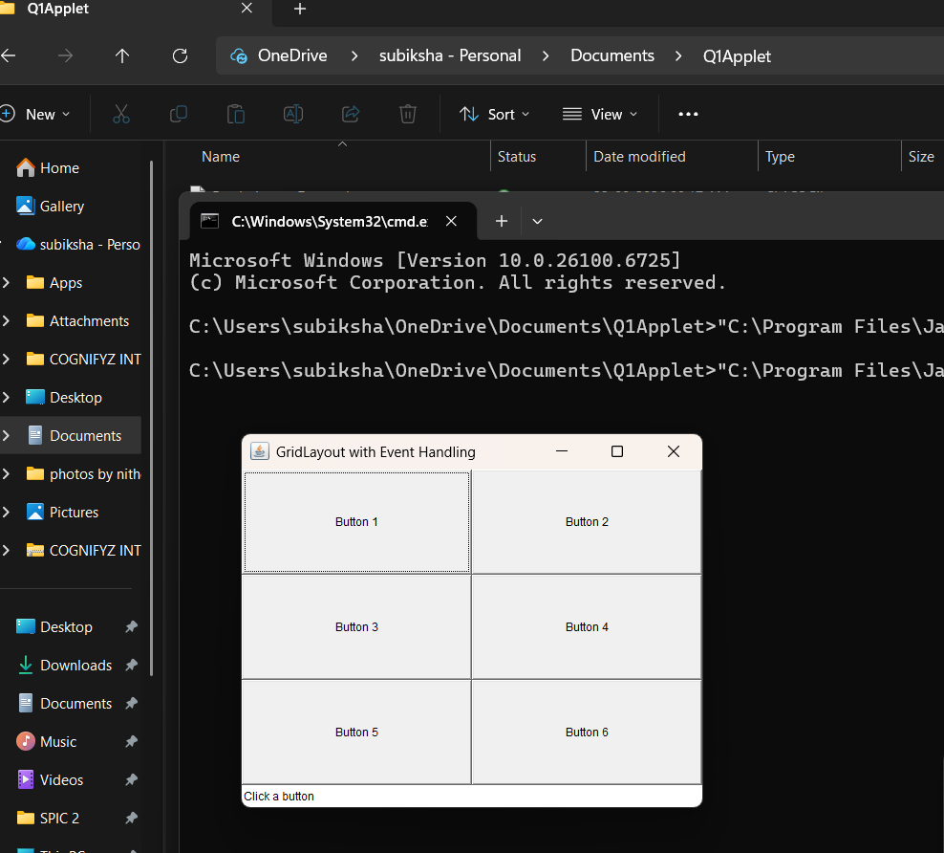

6.
CODE :
import java.awt.*;
import java.awt.event.*;
public class StudentRegistrationForm extends Frame implements ActionListener {
static final Color DEEP_NAVY = new Color(13, 22, 40);
static final Color NAVY_LIGHT = new Color(22, 36, 64);
static final Color GOLD = new Color(212, 175, 55);
static final Color GOLD_SOFT = new Color(240, 217, 150);
static final Color CREAM = new Color(250, 246, 236);
static final Color MAROON = new Color(90, 24, 32);
static final Color EMERALD = new Color(20, 92, 71);
Label nameLabel, rollLabel, deptLabel, emailLabel, phoneLabel, genderLabel, courseLabel;
TextField nameField, rollField, emailField, phoneField;
Choice deptChoice, courseChoice;
Checkbox maleBox, femaleBox;
CheckboxGroup genderGroup;
Button submitButton, clearButton, exitButton;
TextArea outputArea;
GradientPanel formPanel;
StudentRegistrationForm() {
setTitle("Student Registration | Elite Academy");
setSize(600, 660);
setLayout(null);
setResizable(false);
formPanel = new GradientPanel();
formPanel.setLayout(null);
formPanel.setBounds(0, 0, 600, 660);
add(formPanel);
Label crest = new Label("\u2726", Label.CENTER);
crest.setFont(new Font("Serif", Font.BOLD, 26));
crest.setForeground(GOLD);
crest.setBounds(275, 22, 50, 30);
formPanel.add(crest);
Label titleLabel = new Label("ELITE ACADEMY", Label.CENTER);
titleLabel.setFont(new Font("Serif", Font.BOLD, 30));
titleLabel.setForeground(GOLD);
titleLabel.setBounds(100, 52, 400, 40);
formPanel.add(titleLabel);
Label subtitleLabel = new Label("S T U D E N T R E G I S T R A T I O N", Label.CENTER);
subtitleLabel.setFont(new Font("SansSerif", Font.PLAIN, 13));
subtitleLabel.setForeground(CREAM);
subtitleLabel.setBounds(100, 90, 400, 22);
formPanel.add(subtitleLabel);
Divider div1 = new Divider();
div1.setBounds(80, 120, 440, 2);
formPanel.add(div1);
int labelX = 70, fieldX = 230, fieldW = 300, rowH = 42, startY = 150;
nameLabel = luxLabel("Full Name");
nameLabel.setBounds(labelX, startY, 150, 24);
formPanel.add(nameLabel);
nameField = luxField();
nameField.setBounds(fieldX, startY - 3, fieldW, 28);
formPanel.add(nameField);

rollLabel = luxLabel("Roll Number");
rollLabel.setBounds(labelX, startY + rowH, 150, 24);
formPanel.add(rollLabel);
rollField = luxField();
rollField.setBounds(fieldX, startY + rowH - 3, fieldW, 28);
formPanel.add(rollField);

emailLabel = luxLabel("Email Address");
emailLabel.setBounds(labelX, startY + rowH * 2, 150, 24);
formPanel.add(emailLabel);
emailField = luxField();
emailField.setBounds(fieldX, startY + rowH * 2 - 3, fieldW, 28);
formPanel.add(emailField);

phoneLabel = luxLabel("Phone Number");
phoneLabel.setBounds(labelX, startY + rowH * 3, 150, 24);
formPanel.add(phoneLabel);
phoneField = luxField();
phoneField.setBounds(fieldX, startY + rowH * 3 - 3, fieldW, 28);
formPanel.add(phoneField);

deptLabel = luxLabel("Department");
deptLabel.setBounds(labelX, startY + rowH * 4, 150, 24);
formPanel.add(deptLabel);
deptChoice = new Choice();
deptChoice.add("Computer Science");
deptChoice.add("Electronics & Comm.");
deptChoice.add("Mechanical");
deptChoice.add("Civil");
deptChoice.add("Information Technology");
deptChoice.setBounds(fieldX, startY + rowH * 4 - 3, fieldW, 28);
deptChoice.setBackground(CREAM);
deptChoice.setForeground(DEEP_NAVY);
formPanel.add(deptChoice);

courseLabel = luxLabel("Course");
courseLabel.setBounds(labelX, startY + rowH * 5, 150, 24);
formPanel.add(courseLabel);
courseChoice = new Choice();
courseChoice.add("B.E / B.Tech");
courseChoice.add("M.E / M.Tech");
courseChoice.add("MBA");
courseChoice.add("MCA");
courseChoice.setBounds(fieldX, startY + rowH * 5 - 3, fieldW, 28);
courseChoice.setBackground(CREAM);
courseChoice.setForeground(DEEP_NAVY);
formPanel.add(courseChoice);

genderLabel = luxLabel("Gender");
genderLabel.setBounds(labelX, startY + rowH * 6, 150, 24);
formPanel.add(genderLabel);

genderGroup = new CheckboxGroup();
maleBox = new Checkbox("Male", genderGroup, true);
maleBox.setBounds(fieldX, startY + rowH * 6 - 2, 90, 24);
maleBox.setForeground(CREAM);
formPanel.add(maleBox);

femaleBox = new Checkbox("Female", genderGroup, false);
femaleBox.setBounds(fieldX + 110, startY + rowH * 6 - 2, 100, 24);
femaleBox.setForeground(CREAM);
formPanel.add(femaleBox);
Divider div2 = new Divider();
div2.setBounds(80, startY + rowH * 7 + 4, 440, 2);
formPanel.add(div2);
int btnY = startY + rowH * 7 + 22;
submitButton = luxButton("SUBMIT", EMERALD, GOLD_SOFT);
submitButton.setBounds(80, btnY, 130, 38);
submitButton.addActionListener(this);
formPanel.add(submitButton);
clearButton = luxButton("CLEAR", MAROON, GOLD_SOFT);
clearButton.setBounds(235, btnY, 130, 38);
clearButton.addActionListener(this);
formPanel.add(clearButton);
exitButton = luxButton("EXIT", NAVY_LIGHT, GOLD_SOFT);
exitButton.setBounds(390, btnY, 130, 38);
exitButton.addActionListener(this);
formPanel.add(exitButton);
outputArea = new TextArea("", 0, 0, TextArea.SCROLLBARS_NONE);
outputArea.setEditable(false);
outputArea.setBounds(80, btnY + 55, 440, 80);
outputArea.setBackground(new Color(255, 253, 245));
outputArea.setForeground(DEEP_NAVY);
outputArea.setFont(new Font("SansSerif", Font.PLAIN, 12));
formPanel.add(outputArea);
Label footer = new Label("\u00A9 Elite Academy \u2022 Office of Admissions", Label.CENTER);
footer.setFont(new Font("SansSerif", Font.ITALIC, 11));
footer.setForeground(GOLD_SOFT);
footer.setBounds(100, btnY + 145, 400, 20);
formPanel.add(footer);

addWindowListener(new WindowAdapter() {
public void windowClosing(WindowEvent e) {
dispose();
System.exit(0);
}
});
setVisible(true);
}
private Label luxLabel(String text) {
Label l = new Label(text);
l.setFont(new Font("SansSerif", Font.BOLD, 13));
l.setForeground(GOLD_SOFT);
return l;
}

private TextField luxField() {
TextField f = new TextField();
f.setBackground(CREAM);
f.setForeground(DEEP_NAVY);
f.setFont(new Font("SansSerif", Font.PLAIN, 13));
return f;
}

private Button luxButton(String text, Color bg, Color fg) {
Button b = new Button(text);
b.setBackground(bg);
b.setForeground(fg);
b.setFont(new Font("SansSerif", Font.BOLD, 13));
return b;
}

public void actionPerformed(ActionEvent e) {
String command = e.getActionCommand();
if (command.equals("SUBMIT")) {
String name = nameField.getText();
String roll = rollField.getText();
String email = emailField.getText();
String phone = phoneField.getText();
String dept = deptChoice.getSelectedItem();
String course = courseChoice.getSelectedItem();
String gender = genderGroup.getSelectedCheckbox().getLabel();
if (name.isEmpty() || roll.isEmpty()) {
outputArea.setText("\u26A0 Please fill in Name and Roll Number.");
return;
}

outputArea.setText(
"\u2726 Registration Confirmed \u2726\n" +
"Name: " + name + " | Roll No: " + roll + " | Gender: " + gender + "\n" +
"Email: " + email + " | Phone: " + phone + "\n" +
"Department: " + dept + " | Course: " + course
);
}
else if (command.equals("CLEAR")) {
nameField.setText("");
rollField.setText("");
emailField.setText("");
phoneField.setText("");
deptChoice.select(0);
courseChoice.select(0);
maleBox.setState(true);
outputArea.setText("");
}
else if (command.equals("EXIT")) {
dispose();
System.exit(0);
}
}
static class GradientPanel extends Panel {
public void paint(Graphics g) {
Graphics2D g2 = (Graphics2D) g;
int w = getWidth(), h = getHeight();

GradientPaint gp = new GradientPaint(0, 0, DEEP_NAVY, w, h, NAVY_LIGHT);
g2.setPaint(gp);
g2.fillRect(0, 0, w, h);
g2.setColor(GOLD);
g2.setStroke(new BasicStroke(3));
g2.drawRect(10, 10, w - 21, h - 21);
g2.setStroke(new BasicStroke(1));
g2.drawRect(16, 16, w - 33, h - 33);
super.paint(g);
}
}
static class Divider extends Canvas {
public void paint(Graphics g) {
g.setColor(GOLD);
g.fillRect(0, 0, getWidth(), getHeight());
}
}
public static void main(String[] args) {
new StudentRegistrationForm();
}
}

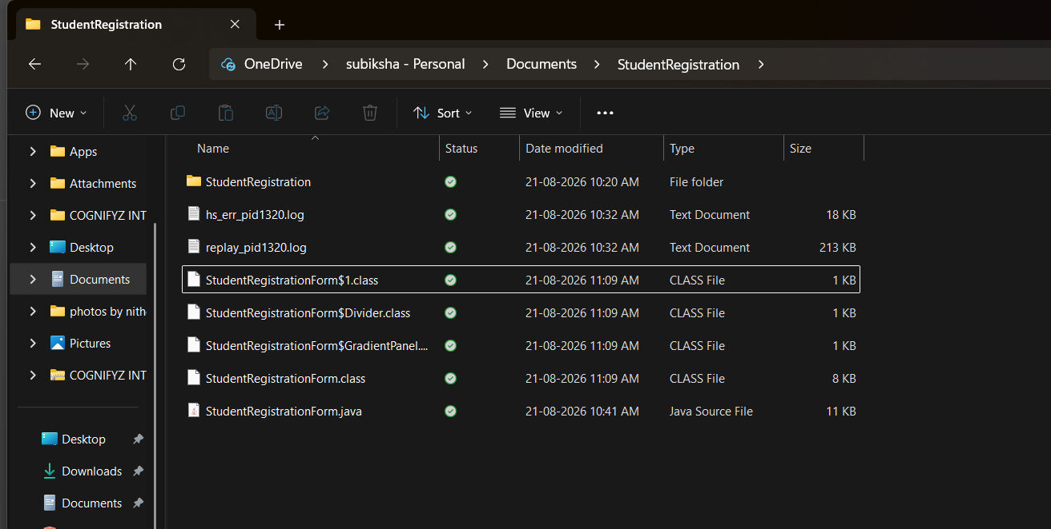

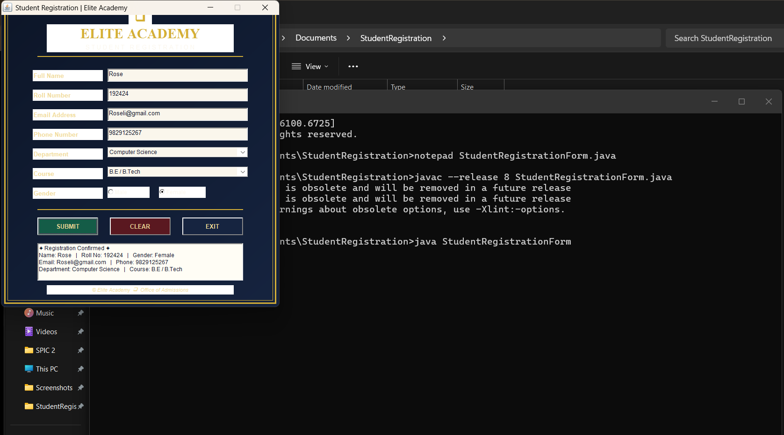

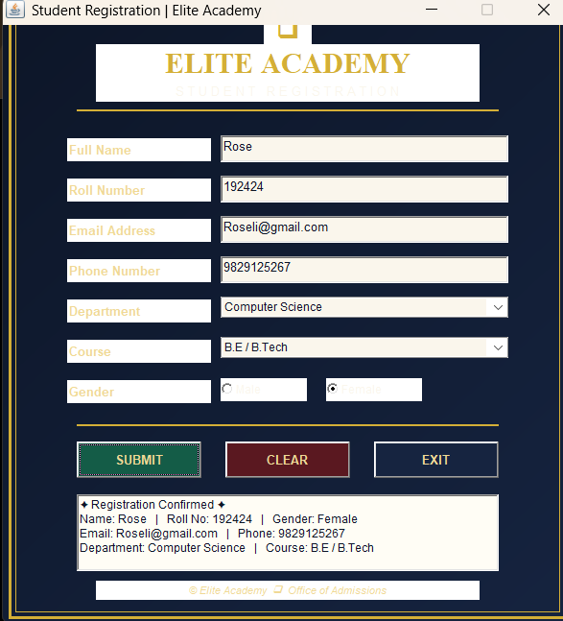

- BorderLayout with Event Handling

CODE :
import java.awt.*;
import java.awt.event.*;

public class BorderLayoutDemo extends Frame implements ActionListener
{
Label header;
TextArea display;
Button home, about, exit;
Button option1, option2;
Button menu1, menu2;

BorderLayoutDemo()
{
setTitle("BorderLayout with Event Handling");
setSize(600, 400);
setLayout(new BorderLayout());
header = new Label("STUDENT APPLICATION", Label.CENTER);
add(header, BorderLayout.NORTH);
display = new TextArea();
display.setText("Welcome to the Student Application");
add(display, BorderLayout.CENTER);
Panel southPanel = new Panel();

home = new Button("Home");
about = new Button("About");
exit = new Button("Exit");

southPanel.add(home);
southPanel.add(about);
southPanel.add(exit);

add(southPanel, BorderLayout.SOUTH);
Panel eastPanel = new Panel();
eastPanel.setLayout(new GridLayout(3, 1));

option1 = new Button("Option 1");
option2 = new Button("Option 2");

eastPanel.add(new Label("OPTIONS"));
eastPanel.add(option1);
eastPanel.add(option2);

add(eastPanel, BorderLayout.EAST);
Panel westPanel = new Panel();
westPanel.setLayout(new GridLayout(3, 1));

menu1 = new Button("Menu 1");
menu2 = new Button("Menu 2");

westPanel.add(new Label("MENU"));
westPanel.add(menu1);
westPanel.add(menu2);

add(westPanel, BorderLayout.WEST);
home.addActionListener(this);
about.addActionListener(this);
exit.addActionListener(this);
option1.addActionListener(this);
option2.addActionListener(this);
menu1.addActionListener(this);
menu2.addActionListener(this);

setVisible(true);
}

public void actionPerformed(ActionEvent e)
{
if(e.getSource() == home)
{
display.setText("Home button clicked");
}
else if(e.getSource() == about)
{
display.setText("About button clicked");
}
else if(e.getSource() == option1)
{
display.setText("Option 1 selected");
}
else if(e.getSource() == option2)
{
display.setText("Option 2 selected");
}
else if(e.getSource() == menu1)
{
display.setText("Menu 1 selected");
}
else if(e.getSource() == menu2)
{
display.setText("Menu 2 selected");
}
else if(e.getSource() == exit)
{
System.exit(0);
}
}

public static void main(String args[])
{
new BorderLayoutDemo();
}
}

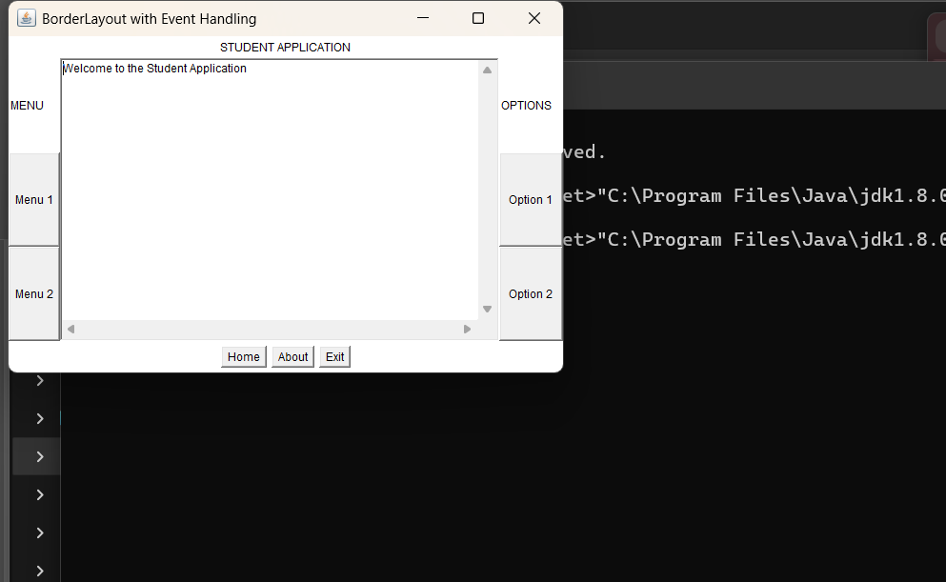

- CardLayout with Event Handling

import java.awt.*;
import java.awt.event.*;

public class CardLayoutDemo extends Frame implements ActionListener {

CardLayout cardLayout;
Panel cardPanel;

TextField nameField;
TextField regField;

Choice department;
Choice year;
TextArea report;
Button nextButton;
Button previousButton;
Button submitButton;
public CardLayoutDemo() {

setTitle("Student Registration - CardLayout");
setSize(600, 450);

cardLayout = new CardLayout();

cardPanel = new Panel(cardLayout);

Panel card1 = new Panel(
new GridLayout(4, 2, 10, 10)
);

card1.add(new Label("Student Information"));
card1.add(new Label(""));

card1.add(new Label("Name:"));

nameField = new TextField();
card1.add(nameField);

card1.add(new Label("Register Number:"));

regField = new TextField();
card1.add(regField);

card1.add(new Label("Department:"));

department = new Choice();

department.add("AI & DS");
department.add("CSE");
department.add("ECE");
department.add("IT");

card1.add(department);

Panel card2 = new Panel(
new GridLayout(3, 2, 10, 10)
);

card2.add(new Label("Academic Information"));
card2.add(new Label(""));

card2.add(new Label("Year:"));

year = new Choice();

year.add("1st Year");
year.add("2nd Year");
year.add("3rd Year");
year.add("4th Year");

card2.add(year);

card2.add(new Label("Status:"));
card2.add(new Label("Active Student"));

Panel card3 = new Panel(
new BorderLayout()
);

card3.add(
new Label(
"Confirmation / Report",
Label.CENTER
),
BorderLayout.NORTH
);

report = new TextArea();

card3.add(report, BorderLayout.CENTER);
cardPanel.add(card1, "Student");
cardPanel.add(card2, "Academic");
cardPanel.add(card3, "Confirmation");

add(cardPanel, BorderLayout.CENTER);
Panel buttonPanel = new Panel();

previousButton = new Button("Previous");
nextButton = new Button("Next");
submitButton = new Button("Submit");

previousButton.addActionListener(this);
nextButton.addActionListener(this);
submitButton.addActionListener(this);

buttonPanel.add(previousButton);
buttonPanel.add(nextButton);
buttonPanel.add(submitButton);

add(buttonPanel, BorderLayout.SOUTH);

addWindowListener(new WindowAdapter() {
public void windowClosing(WindowEvent e) {
dispose();
}
});

setVisible(true);
}
public void actionPerformed(ActionEvent e) {

if (e.getSource() == nextButton) {

cardLayout.next(cardPanel);
}
else if (e.getSource() == previousButton) {
cardLayout.previous(cardPanel);
}

else if (e.getSource() == submitButton) {
String studentName = nameField.getText();
String registerNumber = regField.getText();
String dept = department.getSelectedItem();
String selectedYear = year.getSelectedItem();
report.setText(
"STUDENT CONFIRMATION REPORT\n\n" +
"Name: " + studentName + "\n" +
"Register Number: " + registerNumber + "\n" +
"Department: " + dept + "\n" +
"Year: " + selectedYear + "\n\n" +
"Registration Successful!"
);
cardLayout.show(
cardPanel,
"Confirmation"
);
}
}
public static void main(String[] args) {
new CardLayoutDemo();
}
}

